|  |  |  |
| --- | --- | --- |
| Product Name | SIM card connector |  |
| Card connection method | Self-retracting type |  |
| Card type | NanoSIM card |  |
| Connector type | Card slot |  |
| Maximum height of the body | 1.25mm |  |
| Contact material | Copper alloy |  |
| Contact coating | Gilding |  |
| Operating temperature range | -40℃~+85℃ |  |
| Welding temperature (maximum value) | 260℃ |  |

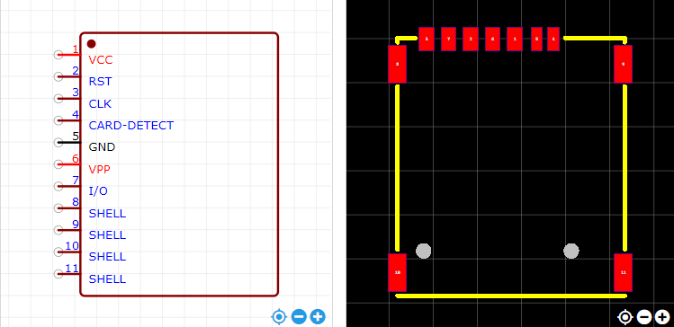

<https://item.szlcsc.com/353303.html>